**DAILY ONLINE ACTIVITIES SUMMARY**

|  |  |  |  |  |  |  |  |
| --- | --- | --- | --- | --- | --- | --- | --- |
| **Date:** | **15-06-2020** | | | | **Name:** | **B.A.SOHANKUMAR** | |
| **Sem & Sec** | **4TH SEM A** | | | | **USN:** | **4AL18CS013** | |
| **Online Test Summary** | | | | | | | |
| **Subject** | | **-----** | | | | | |
| **Max. Marks** | | **-----** | | **Score** | | **-----** | |
| **Certification Course Summary** | | | | | | | |
| **Course** | **DATA SCIENCE WITH PYTHON** | | | | | | |
| **Certificate Provider** | | | **GLA** | **Duration** | | | **11.2 HOURS** |
| **Coding Challenges** | | | | | | | |
| **Problem Statement: Write a java program to find if a string is a k palindrome or not.** | | | | | | | |
| **Status: EXECUTED** | | | | | | | |
| **Uploaded the report in Github** | | | | **YES** | | | |
| **If yes Repository name** | | | | **LOCKDOWN CODING** | | | |
| **Uploaded the report in slack** | | | | **YES** | | | |

**CERTIFICATION COURSE DETAILS:**

Course:Data science with python

Today completed topics are Density Graphs demo,Stats Module demo,Introduction to Logistic Regression,Sigmoid Curve and Logloss Function,Model cases of Logistic Regression,Advantages and Disadvantages-2,Practice with Data Sets and successfully completed the course and taken the assessment quiz.

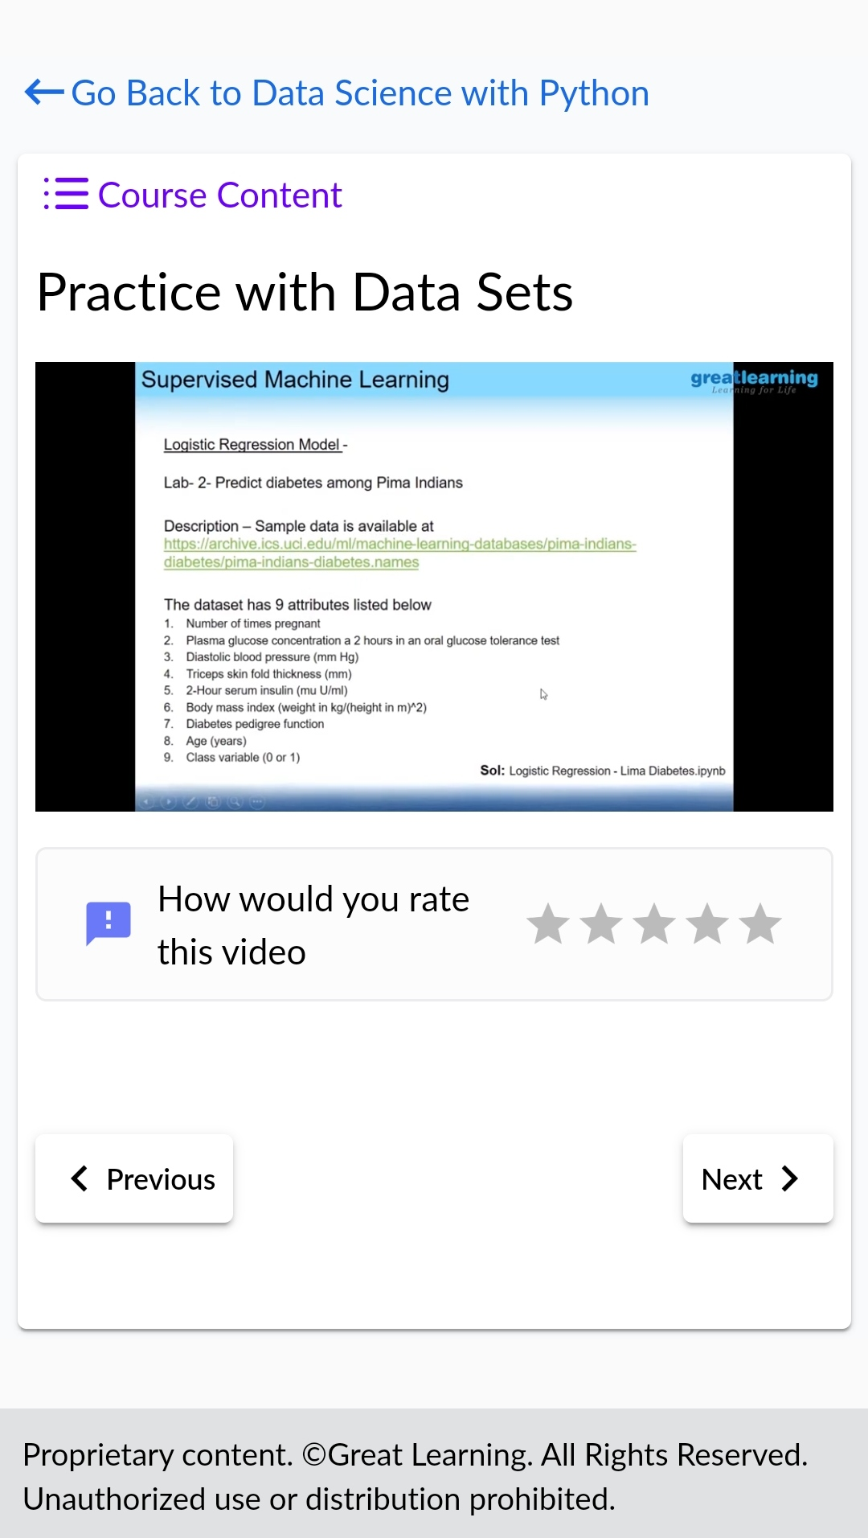 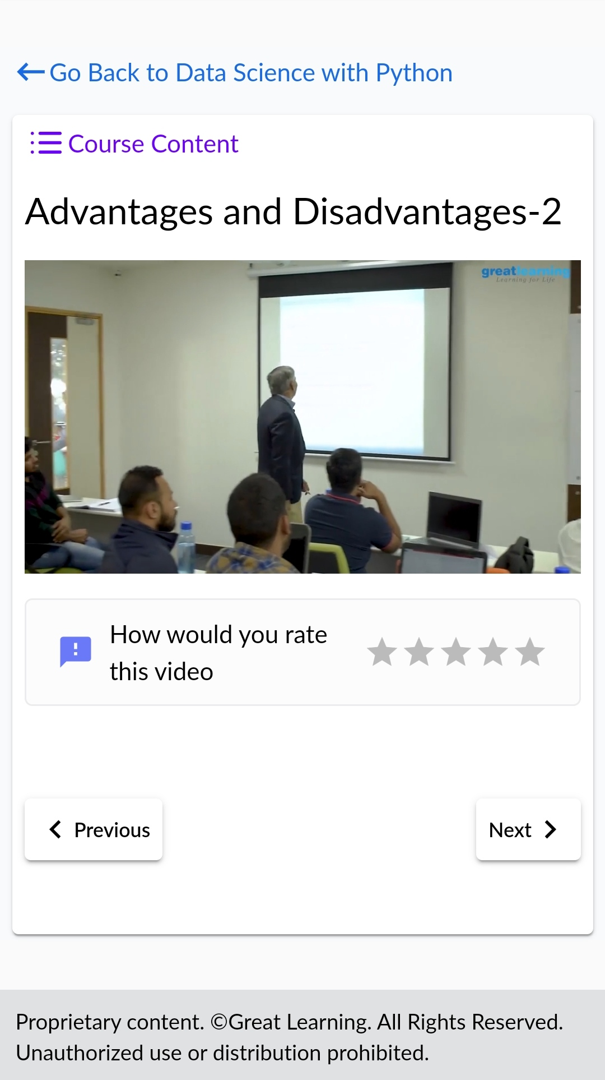

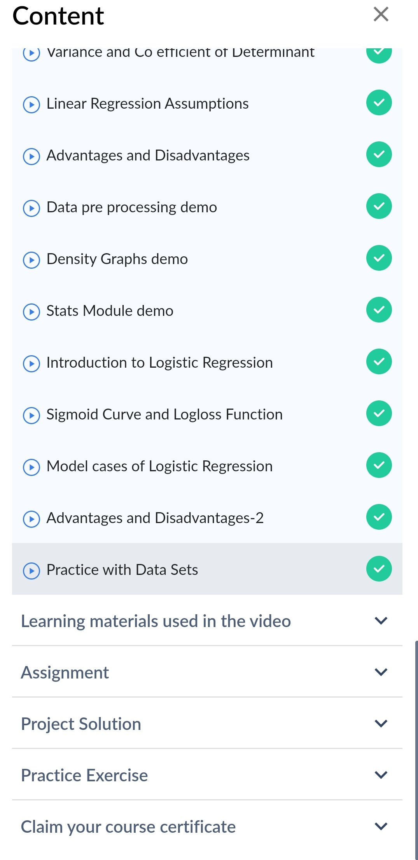

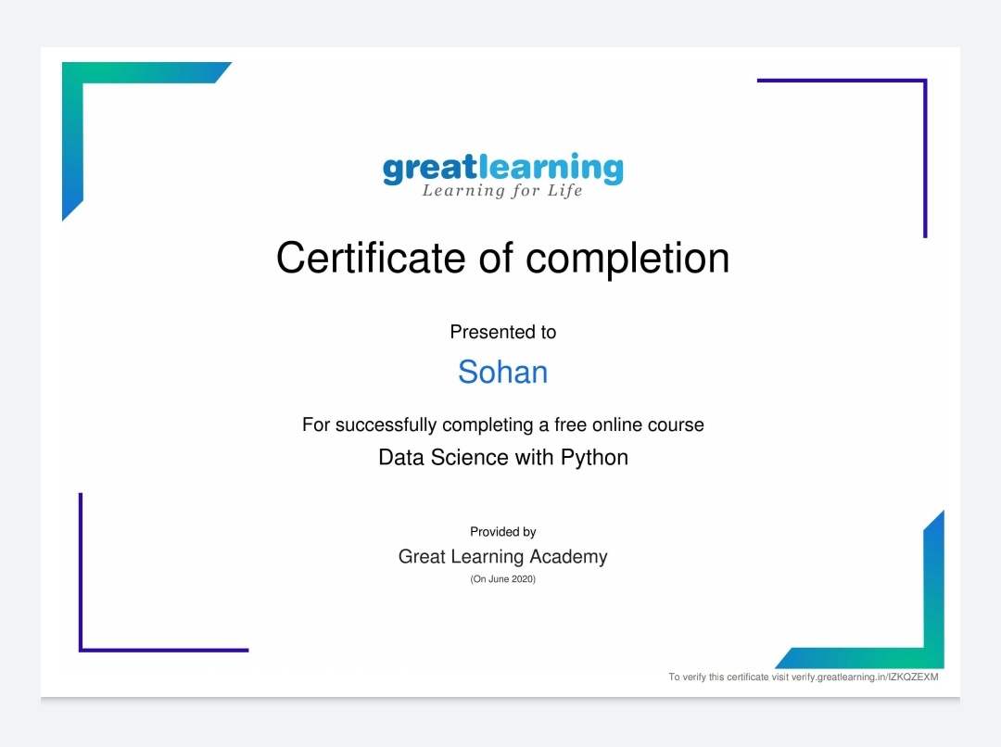

Above certificate is awarded for the completion of this course.

**CODING CHALLENGES:**

1.Write a java program to find if string is a k palindrome or not.A string is k palindrome if it can be transformed into a palindrome on removing at most k characters from it. Your task is to complete the function is_k_palin which takes two arguments a string str and a number N . Your function should return true if the string is k palindrome else it should return false.

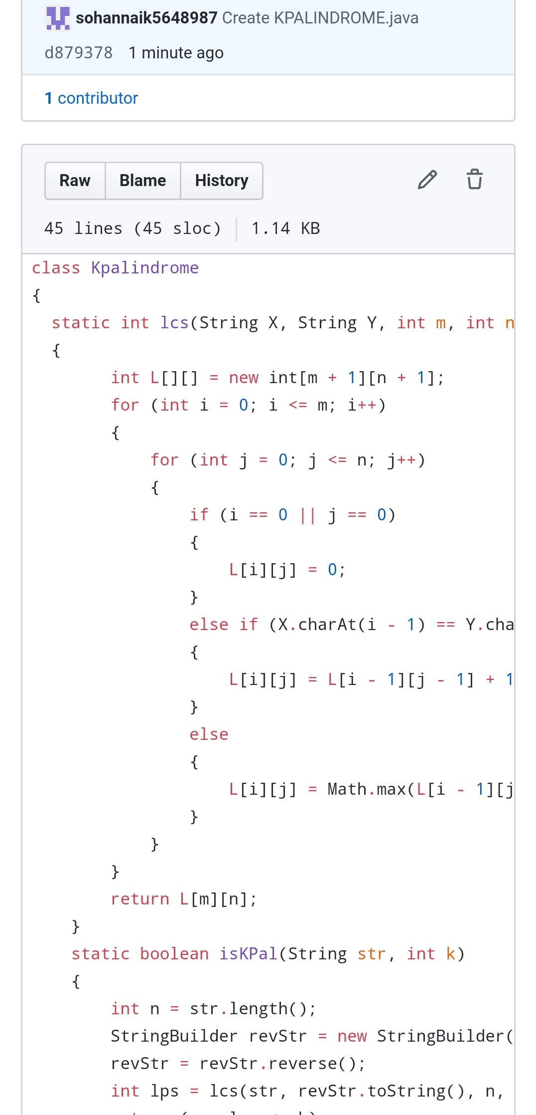

REPOSITORY LINK:https://github.com/sohannaik5648987/JAVA-CODING